Communities United, Inc.
Lexington Creative Start
2023
Director: Patty Brancato - Assistant Director: Jeanmarie Peluso -Family Support Specialist : Jara Ortiz
Classroom 3 - Toddlers 8:30am-2:30 pm - Ms. Phoebe, Ms. Jillian, Ms. Nermin
Classroom 2 - Half Day Preschool 8:30am-12:30 pm - Ms. Patty, Ms. Fatima
Classroom 1 - Pre-K 8:45am-2:45 pm - Ms. Jara, Ms. Amber, Ms. Thallita

Curriculum Corner
This month each classroom will be learning all about Fairy Tales, Construction & Building.
The children will be creating their own Box City this month.
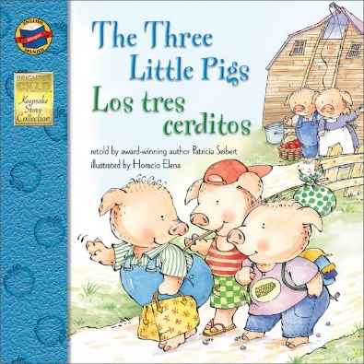
For the month of March each classroom will be reading the following books:
Classroom 1– “ The Princess and The Pea” by Hans Christian Andersen.
Classrooms 2/ 3- “The Three Little Pigs” by Patricia Seibert.

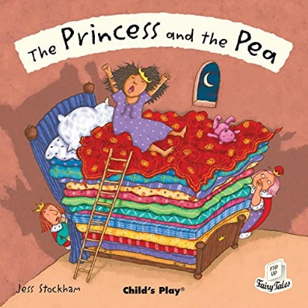
Here’s a look at the books we will be reading this month…

WINTER LITERACY CHALLENGE!
This month the literacy challenge will be to read a total of 300 books. Classroom 1 made a nice barometer rating scale that we will be using to track our reading progress. It is located in the front entrance for all to see. Each class will provide you with our literacy handouts to take home and write down the numbers of books your child is reading, then as always bring them in for us to count and hang on our board. Let’s see how high we can get that Barometer!
This month is all about Fairy Tales! (A perfect time to read lots of books for our literacy challenge). Reading to your child is one of the best things you can do for your child. Studies show, children who are read to do better in school!

Parent-Teacher Conferences will take place this month. We look forward to meeting with all parents to share your child’s progress.
March 8- 3-4p Open House
March 9- Family Event and Dentist Visit- 10:30- 11:15a.
March 12 - Daylight Savings Time- Don’t forget to move the clocks forward one hour. Think: Spring Forward!

March 13- Agency Closed – Professional Development Day for Staff
March 14- 3-4p Open House
March 15- 10 am Policy Council Meeting – Virtual zoom meeting this month
March 20- 10-11a Parent Meeting and SPRING Begins!
March 21- 12-12:30pm and 2-3pm Open Air Market
March 28- 3:30- 6:30p Open House
* The Week Of The Young Child is April 1st to April 7th. – Stay tuned for more details on the fun activities that will be taking place each day.
REMINDERS:
Classroom 1 (Duration) will NOT be having classes on Mondays this month.
- Please have your own mask available for use during daily drop off/pick up. Masks have to cover your nose and mouth at all times while inside the center.
● Please bring in weather appropriate clothing (jackets, hats, gloves, boots)
● Please make sure ALL of your child’s belongings are labeled including water bottles, backpacks, etc.
● Please have extra clothes in your child's backpack in case of an accident.
● If your child is in a diaper, please make sure (s)he has their own diapers.
● Please call the center by 9:00 AM if your child is going to be absent.
This Photo by Unknown Author is licensed under CC BY-NC-ND

