Communities United, Inc.
Lexington Creative Start
2023
Curriculum Corner
This month each classroom will be learning about how important our oral health is in staying
healthy. We will also be studying the many professions that keep our communities safe
and thriving such as police men and women, teachers, firefighters, trash collectors and more!

For the month of February each classroom will be reading the following books:
Classroom 1– The Berenstain Bears Visit The Dentist by Stan and Jan Berenstain.
Classrooms 2/3- Fire Engines by Anne Rockwell &
Moose's Loose Tooth by Jaqueline A. Clark
Here’s a look at the books we will be reading this month…
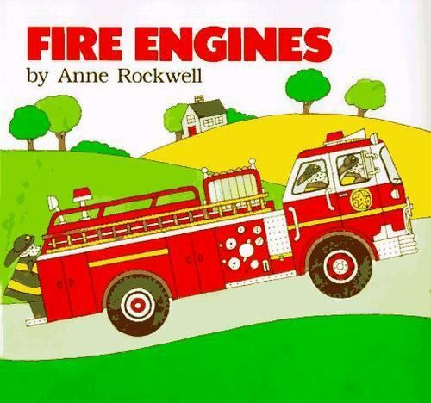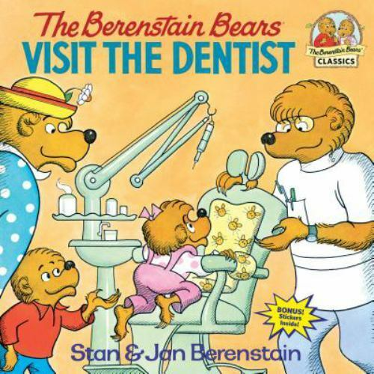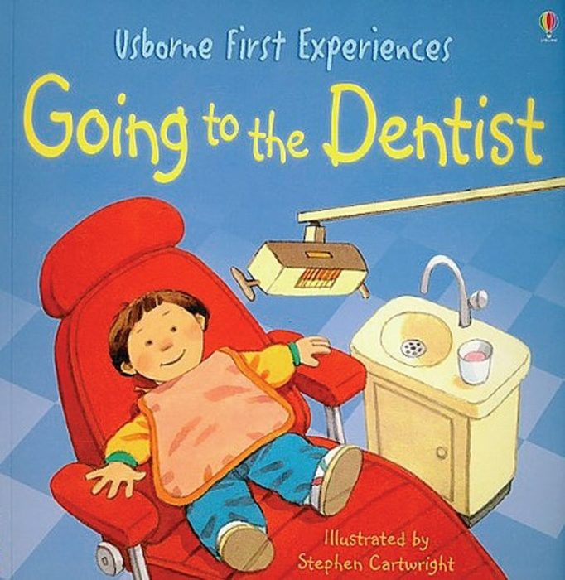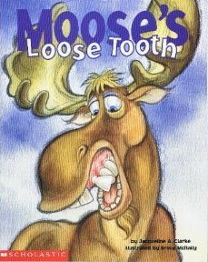
Upcoming Dates:
February 9- 3-4p Open House for new parent
February 13- 3-4p Open House for new parents
February 13 10-11a Parent Meeting
February 14- Advocacy Day for Early Childhood Education at the State House
February 16 Open Air Market – 12:30 and 2:00 PM
February 20- AGENCY CLOSED- Presidents Day
February 21-24th Winter Break – No School
February 28- 3:30- 6:30p Open House for New Parents
Family Event - TBD

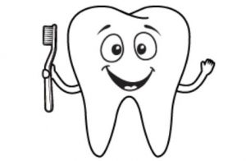
This month is all about ORAL HEALTH!

As adults, we know how important practicing good oral hygiene is for our overall health, However, our
children do not even think about this. Parents are encouraged to model for children what taking
care of our teeth looks like on a daily basis. The best place to begin is by having them watch you
as you brush your teeth and if they are old enough, assisting them in brushing their own teeth
at the same time. Developing this healthy habit from an early age, increases their overall wellness too.
Below are some facts from the CDC that are helpful to know as we begin this journey of good oral health.

“Cavities (also known as caries or tooth decay) are one of the most common chronic diseases of childhood
in the United States. Untreated cavities can cause pain and infections that may lead to problems
with eating, speaking, playing, and learning. Children who have poor oral health often
miss more school and receive lower grades than children who don’t.
- More than half of children aged 6 to 8 have had a cavity in at least one of their baby (primary) teeth.
- More than half of adolescents aged 12 to 19 have had a cavity in at least one of their permanent teeth.
- Children aged 5 to 19 years from low-income families are twice as likely (25%) to have cavities,
compared with children from higher-income households (11%).

- The good news is that cavities are preventable. Fluoride varnish can prevent about one-third (33%)
of cavities in the primary (baby) teeth.
- Children living in communities with fluoride in their tap water have few cavities than children
whose water is not fluoridated.
- Similarly, children who brush daily with fluoride toothpaste will have fewer cavities.” - CDC

REMINDERS:

Classroom 1 (Duration) will be having classes on Mondays this month.
- Please have your own mask available for use during daily drop off/pick up.
● Please bring in weather appropriate clothing (jackets, hats, gloves, boots). We go outside everyday,
weather permitting.
- Especially important, please bring in SNOWPANTS to keep your child warm outside. Children love to play in the snow.
● Please make sure ALL of your child’s belongings are labeled including water bottles, backpacks, etc.
● Please have extra clothes in your child's backpack in case of an accident.
● If your child is in a diaper, please make sure (s)he has their own diapers.
● Please call the center by 9:00 AM if your child is going to be absent.

